

Technical Specification Document
APEXPEAK PTE LTD

Author: [Sahaya john raj.X]
Date: [2014,August 1st]
Version: [1.0]

Document Control
Document location
Location
Abeo Electra , Chennai, Tamilnadu, India
Author
Position | Name | Contact no
 | Sahaya john raj.X | +91 9080182005
Revision history
Version | Issue date | Author/editor | Description/Summary of changes
Reviewed by
Version | Issue date | Name | Position | Reviewdate
Approvals
Approval refers to the approver’s acceptance of the content and overall intention of this document, including acceptance of any commitments described in order to successfully deliver the initiative. The approver, where relevant, also confirms that this document complies with relevant strategies, policies and regulatory requirements.
Version | Issue date | Name | Position | Approval date
Related documents
Document | Location
Table of Contents
1 INTRODUCTION 4
1.1 Objectives 4
1.2 Scope 4
1.3 Development Environment 4
2 Functionality 5
2.1 Use Case Diagram 5
2.2 Site Map 5
2.3 Field Matrix 8
3 Achitecture 9
3.1 Architecture Overview 9
4 Design 10
4.1 Object Diagram 10
4.3 Data Dictionary 11
5 CODE 12
5.1 Coldfusion File Names and Structure 12

1. INTRODUCTION

1.1 Objectives
This document is a generic technical design document for the projects. It provides guidance which is intended to assist the relevant management, technical staff or client. It is also useful background reading for anyone involved in customization or monitoring the Pastel Export Customization interface.

1.2 Scope
This preface describes:
- Design UI for passing some valid inputs and select the CSV file locally saved using the browse option.
- Create the mapping table(Non object) in SAP B1, field code contains GL account of bibby`s pastel system and name contains of SAP GL account.
- After the button click in the UI, identify the CSV file from the location and import it in data view.
- Get the data`s for respective reference and start doing the validation
- Validating the CSV G/L account code have corresponding SAP G/L account in the mapping table.
- Validating the total credit amount with total debit amount whether its same / not.
- Any one of this validation fails, the system should prompt some related information's, so that the user get notified.
- If it`s not fails, the system will post the respective transaction in SAP B1.

1.3 Development Environment
- This Solution is a True Add-on, Developed in VS2010 with using SAP B1 9 DLLs.

IDE : Visual Studio 2010
.Net Framework : 3.5
SAP Components : SAP B1 SDK, UIAPI, DIAPI

2. Functionality

2.1 Use Case Diagram

SAP B1

UI Input Screen
Parameters -> posting date, Remarks, Path of the file.

Validation
1) Account code checking with the mapping table whether it`s present / not. If there it returns TRUE otherwise FALSE.
2) Credit and Debit amount checking, whether it`s same or difference. If same it returns TRUE otherwise FALSE
3) if any one condition fails / return FALSE , this function will prompt the proper information and stop the further process.

Journal Entry Posting
While posting the JE in SAP B1, if any error occurs this function will rollback all the transactions and prompt the error information.

2.2 Site Map
The applications site map showing the navigation streams.

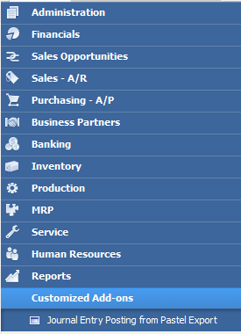

SAP B1 Menu -> Customized Add-ons -> Journal Entry Posting from pastel export.

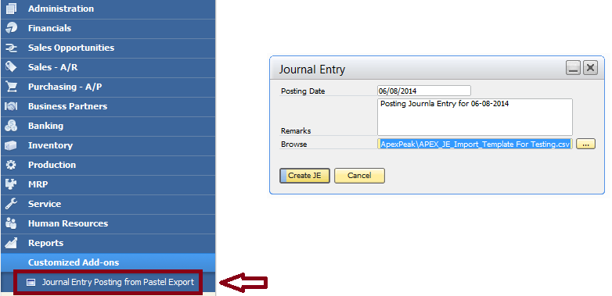

Validations:

#1
- If GDC is G, the AccNumber must have a corresponding SAP G/L Account in the mapping table. If there is no corresponding SAP G/L Account found in the mapping table, the program should pop up an error message to the user and no import should be made to SAP
- If GDC is D → use the SAP G/L Debtor Account Number assigned to Debtor in the mapping table, i.e. all “D” AccNumbers will go into one SAP Debtor G/L Account.
- If GDC is C → use the SAP G/L Creditor Account Number assigned to Creditor in the mapping table, i.e. all “C” AccNumbers will go into one SAP Creditor G/L Account

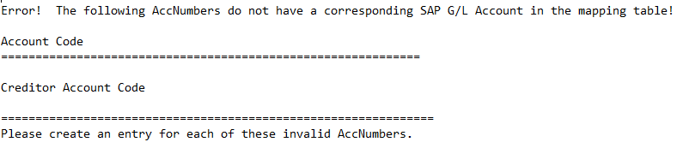

#2
- If the SAP G/L Account Code in the mapping table is not found in table OACT (SAP COA) or Postable field is not equal to ‘Y’ then throw error

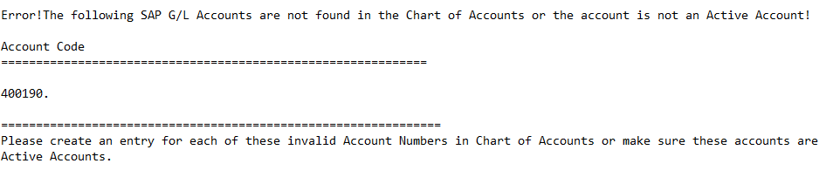
#3
1. For each Journal Entry, the Total Debit must be equal to the Total Credit. If not equal, the program should pop up an error message to the user and no import should be made to SAP

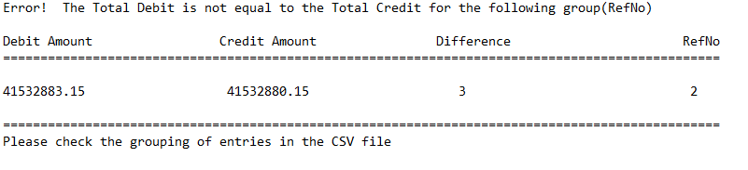SAP B1 Menu -> Financials -> Journal Entry.

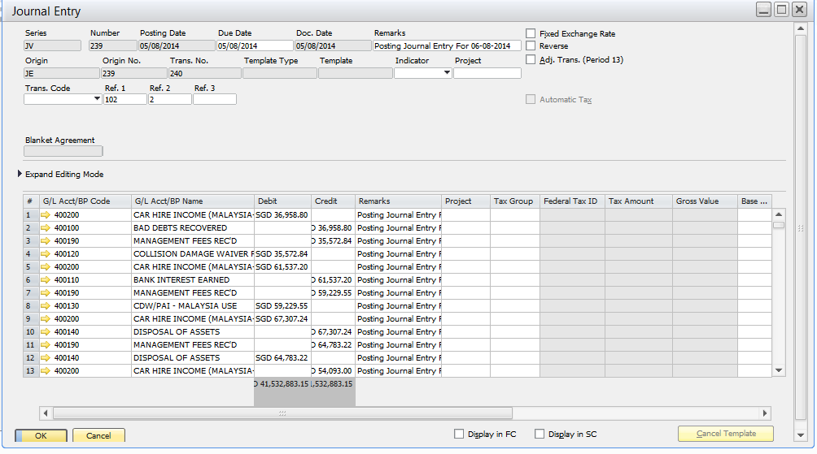

2.3 Field Matrix
Bibby’s Pastel system in South Africa has a different Chart of Accounts with Singapore’s SAP Business One. In order to import the data, G/L Account mapping between the two systems is needed. A User Defined Table (UDT) has been created in SAP Business One under the company Bibby(BIBBY_LIVE database) to serve this purpose.

This table contains the G/L Account Mapping between Bibby’s Pastel system and SAP Business One.

UDT Name: dbo.[@BIBBY_ACCT_MAPPING]
UI Column Name | Bibby Acct | Apex Peak SG Acct
Column Description | Pastel System G/L Account | SAP G/L Account
 | Sample Data
DB Column Name | Code | Name
 | G/L Account 1 | SAP G/L Account 1
 | G/L Account 1 | SAP G/L Account 2
 | D | SAP G/L Debtor Account
 | C | SAP G/L Creditor Account

User needs to provide the G/L account mapping during design stage. After go-live, user will have to maintain this table.

Tools → User-Defined Windows → BIBBY_ACCT_MAPPING – Bibby Account Mapping

3. Architecture

Architecture Overview


GUI
Pastel Export Customization
Journal Entry
Finance Module

It will start with validation process one by one, if its succeed it will step in next validation, once the validation are completed. It will generate the Journal Entry in SAP B1.

Business Logic

SQL Server (DB)

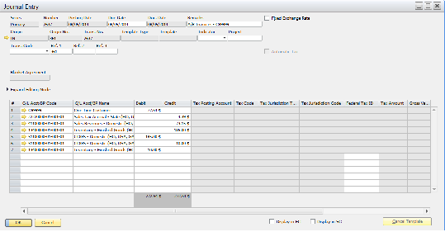

4. Design

Object Diagram
A diagram of all of the participating classes and all of the objects methods.

modMain.vb
ClsEventHandler.vb

Calling ConnectDICompSSO()
Calling AddMenuItems()
SBO_Application_AppEvent()
SBO_Application_MenuEvent()
Calling LoadFromXML()
SBO_Application_ItemEvent()
BeforeAction = False
EventType = ItemPressed
ItemUID = "Item_8"
Calling FillOpen()
ItemUID = "Item_6"
Calling GetDataView()
Calling Validation()
Calling JournalEntryPosting()
BeforeAction = True
EventType = ItemPressed
ItemUID = "Item_6"
Calling HeaderValidation()

modCommon.vb

Description ConnectDICompSSO()
Description AddMenuItem()
Description LoadFromXML()
Description FillOpen()
Description HeaderValidation()
Description GetDataViewFromCSV()
Description GetSingleValue()
Description Del_Schema()
Description Create_Schema()
Description GetDate()
Description Write_TextFile_Account()
Description Write_TextFile_ActiveAccount()
Description Write_TestFile_Amount()
Description ConvertStringToDate()

modJournal.vb

Description Validation()
Calling AccountCodeChecking()
Description JournalEntryPosting()
Calling GetSingleValue()
Calling ConvertStringToDate()
Description AccountCodeChecking()

modLogging.vb

Description WriteToLogFile()
Description
WriteToLogFile_Debug()

Data Dictionary
Descriptions of all the fields and Tables in the system.
Bibby’s Pastel system in South Africa has a different Chart of Accounts with Singapore’s SAP Business One. In order to import the data, G/L Account mapping between the two systems is needed. A User Defined Table (UDT) has been created in SAP Business One under the company Bibby(BIBBY_LIVE database) to serve this purpose.
This table contains the G/L Account Mapping between Bibby’s Pastel system and SAP Business One.
UDT Name: dbo.[@BIBBY_ACCT_MAPPING]

UDF Details
- BibbyAFCode Alphanumeric(40)
- BibbySGCode Alphanumeric(40)

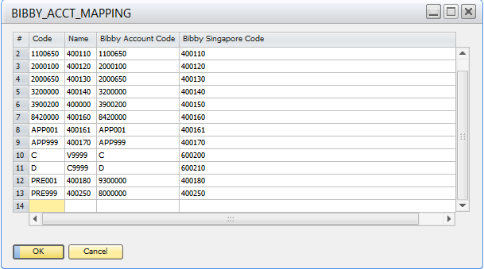

5. Code

Coldfusion File Names and Structure
The purpose for the methods/ function in this solutions.

Module and Class Name:

- modMain.vb
Initializing some public variables and calling the SAP Company connection method.
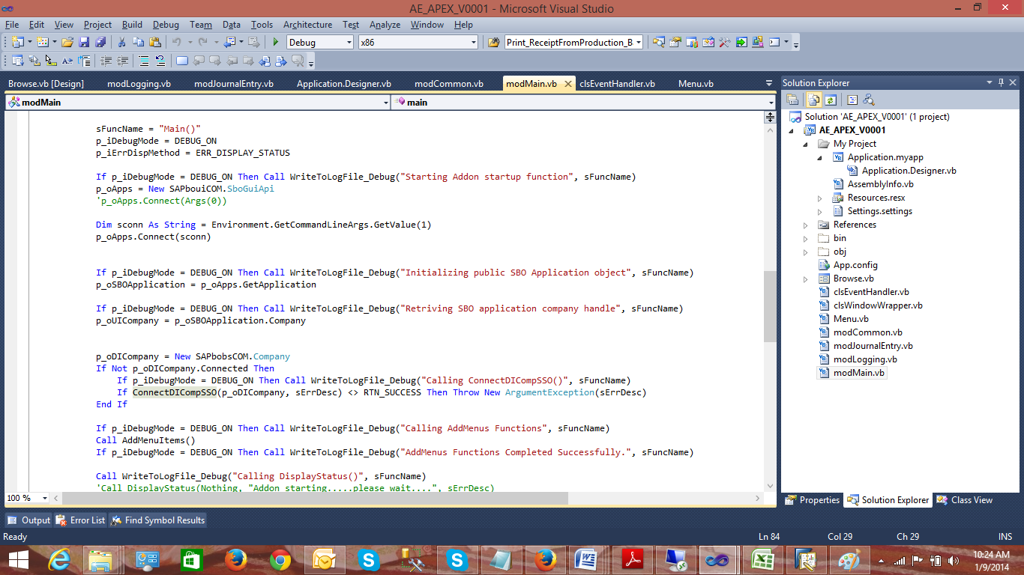

- clsEventHandler.vb

Event handler class having the main three events
- AppEvent
It will triggers when the connections / disconnection happen with the company database.
- MenuEvent
It will triggers any menu is clicked / pressed.
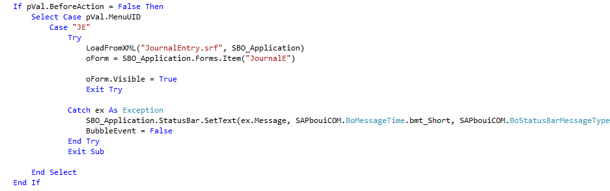
- ItemEvent

For Browse - Button Click
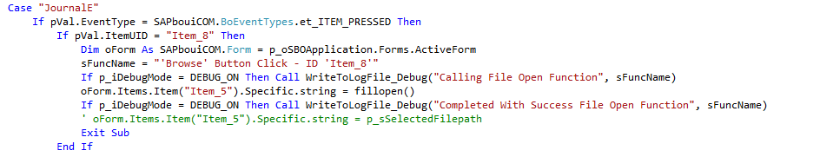

For Journal Entry Creation - Button Click

GetDataviewFromCSV() - This function will handles the data export from CSV files to DataView "p_oDVJE" .
Validation() - This function will handles the validation part and if any validation fails, it will prompt the msg.
JournalEntryPosting() - This function will handles to generate the Journal entry in SAP B1.

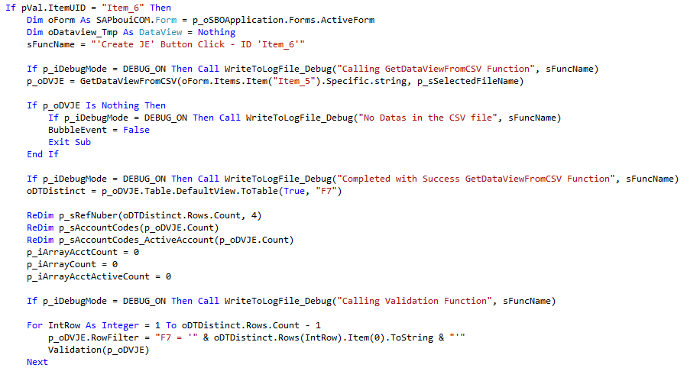
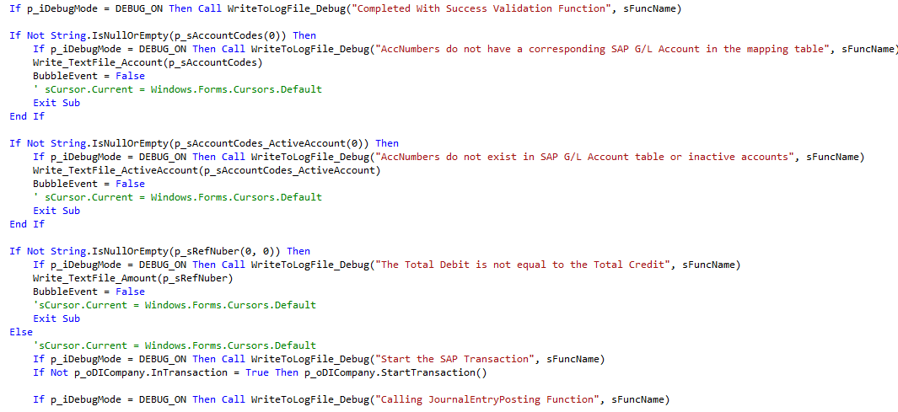
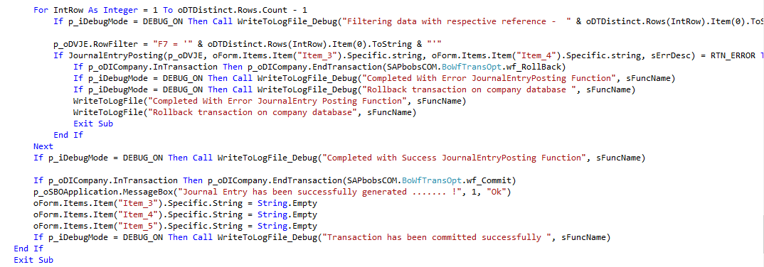
- modCommon.vb

AddMenuItems() - Creating the Menus in the SAP B1 GUI.
LoadFromXML() - Used to open the .srf file.
FillOpen() - Handles the Open Dialogue Box for navigate the CSV file.
HeaderValidation() - Validates the GUI .
GetDataViewFromCSV() - Export the CSV data into Dataview.
GetSingleValue() - Returns the SAP COA.
Create_Schema() - Helps to retrieve the exact data in the CSV.
Del_Schema() - After exporting the CSV file , it will delete the schema.
GetDate() - Helps to get the company Date format for posting the Journal Entry.
Wirte_TextFile_Account() - If account is missing in the mapping table , it will write into the text file and finally it
will prompt as a message.
Write_TextFile_ActiveAccount() - it will write into the text file if the account is not active / invalid.
Write_TextFile_Amount() - it will write into the text file if the credit and debit amount is not same.
ConvertStringToDate() - This function will convert the string value "d/M/yyyy" to Date type "yyyy/M/d"

